1. **Print the first 10 natural numbers using for loop**

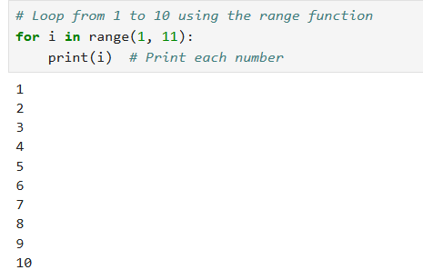

1. **Python program to check if the given string is a palindrome**

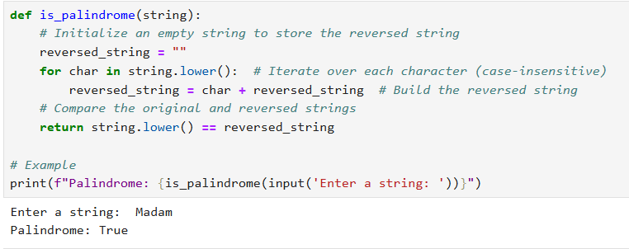

1. **Python program to check if a given number is an Armstrong number**

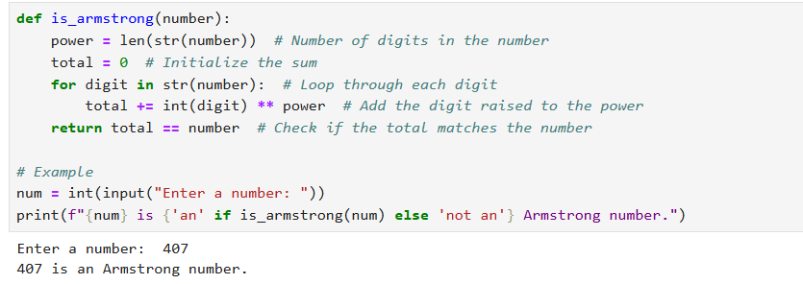

1. **Python program to get the Fibonacci series between 0 to 50**

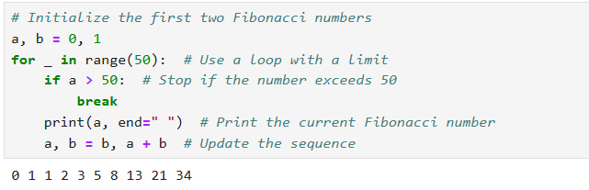

1. **Python program to check the validity of password input by users**

